USE WORD CONTEXT
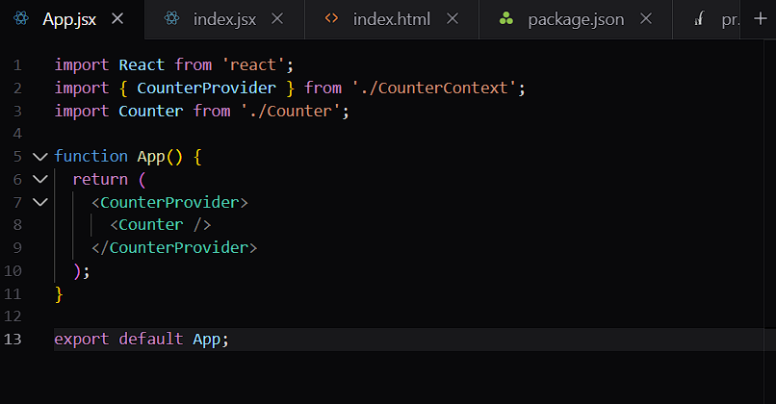
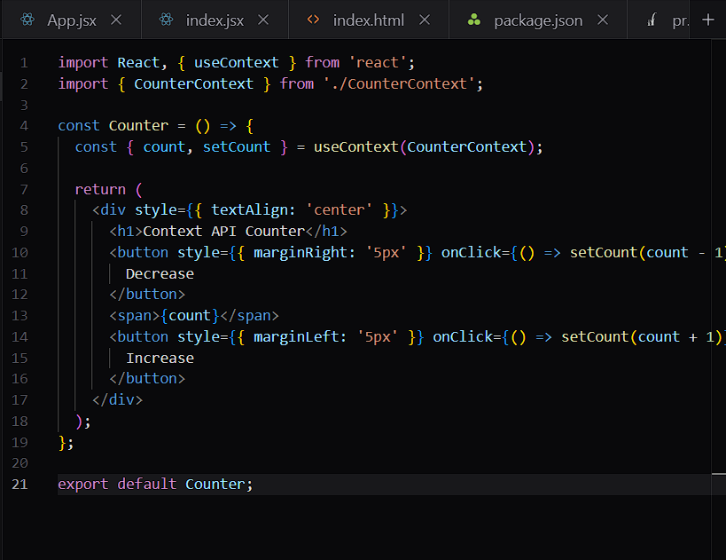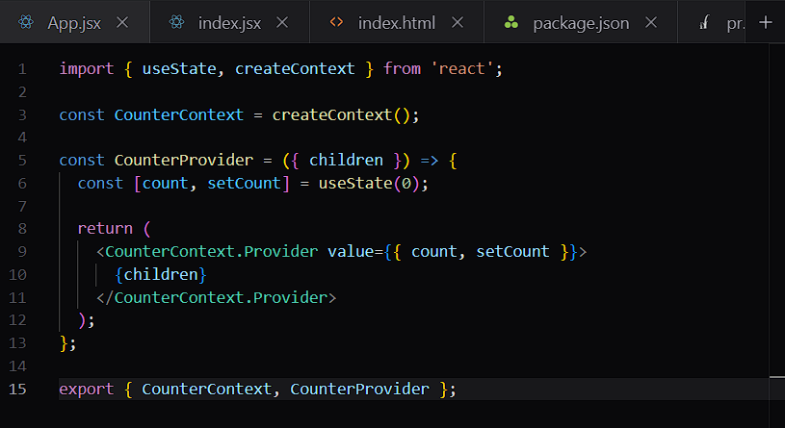
ROUTER
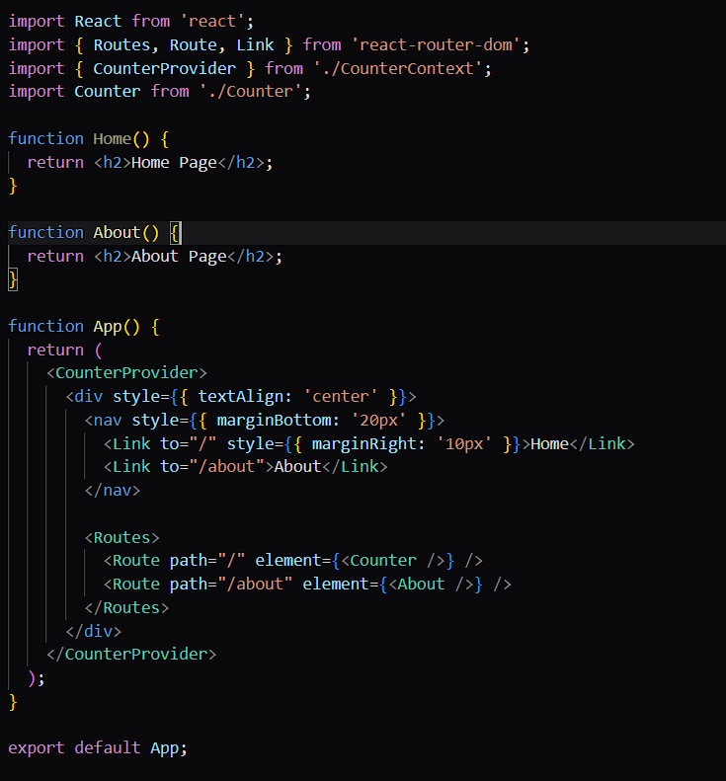
Link
- Used for clickable navigation
- Like an <a> tag, but it does not reload the page
<Link to="/about">About</Link>

Route
- Defines one path and what component should show for that path
<Route path="/about" element={<About />} />
This means: when the URL is /about, render <About />.
Routes
- A container that holds all your Route components
- It tells React Router to pick the best matching route
<Routes>
<Route path="/" element={<Counter />} />
<Route path="/about" element={<About />} />
</Routes>
Simple way to remember
- Link = click to go somewhere
- Route = page rule
- Routes = group of page rules
Yes — Link is like an anchor tag (<a>), but for React Router.
Similarity
<Link to="/about">About</Link>
is similar to:
<a href="/about">About</a>
Difference
- <a> causes a full page reload
- <Link> changes the URL without reloading the page
Why use Link
- faster navigation
- keeps React app state alive
- works with client-side routing
In your app
Use:
<Link to="/about">About</Link>
instead of:
<a href="/about">About</a>
If you want, I can also explain NavLink vs Link.
>
what about the routes? are they invinsible in the app?
Yes — <Routes> and <Route> are usually invisible in the UI.
Why?
They are not HTML elements. They are React Router logic components:
- <Routes> decides which route matches the URL
- <Route> says what component to show for that URL
What you actually see
Only the component inside element gets rendered, like:
<Route path="/about" element={<About />} />
So the user sees <About />, not <Route>.
In your app
- On / you’ll see Counter
- On /about you’ll see About Page
Important
They are only “invisible” if you use them correctly inside <BrowserRouter>.

ZUSTAND LIBRARY IN THE COUNTRY
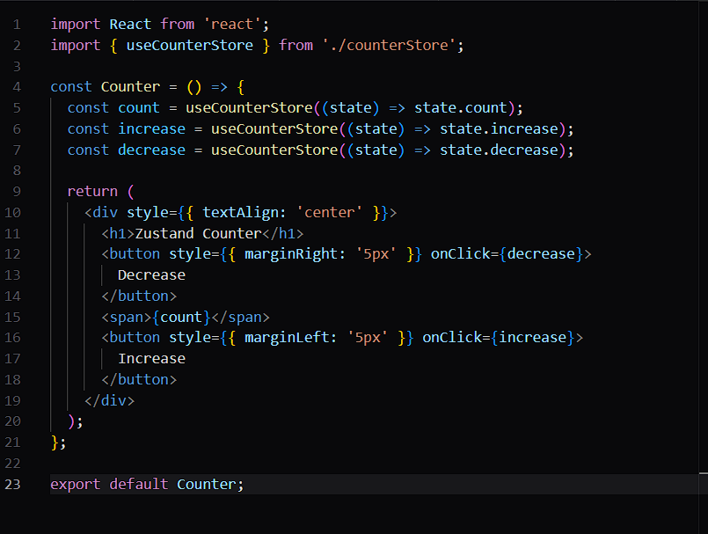
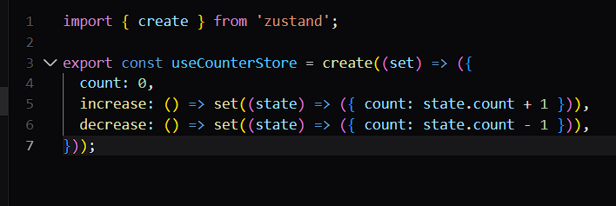
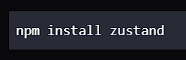

REDUX TOOLKIT LIBRARY
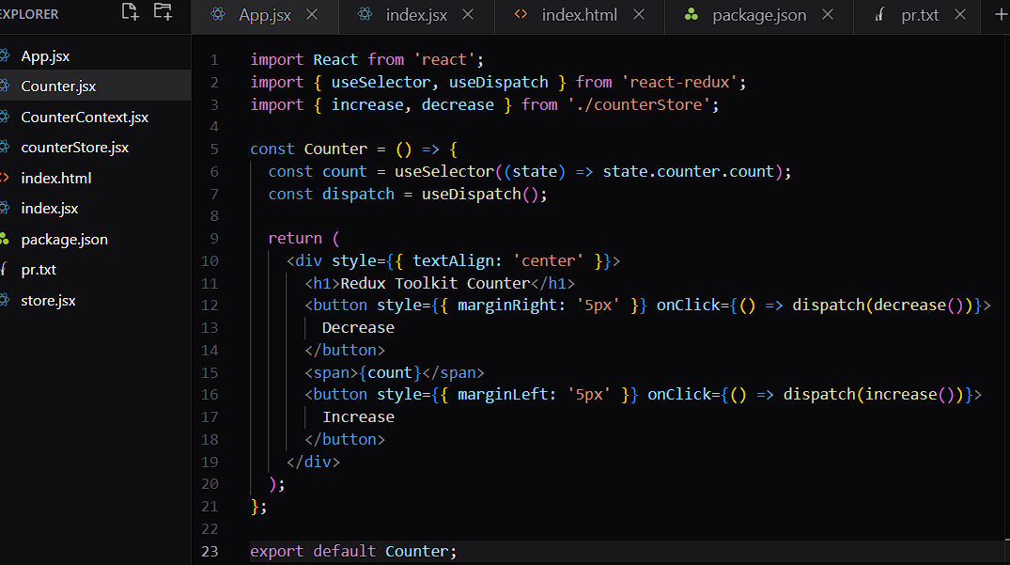
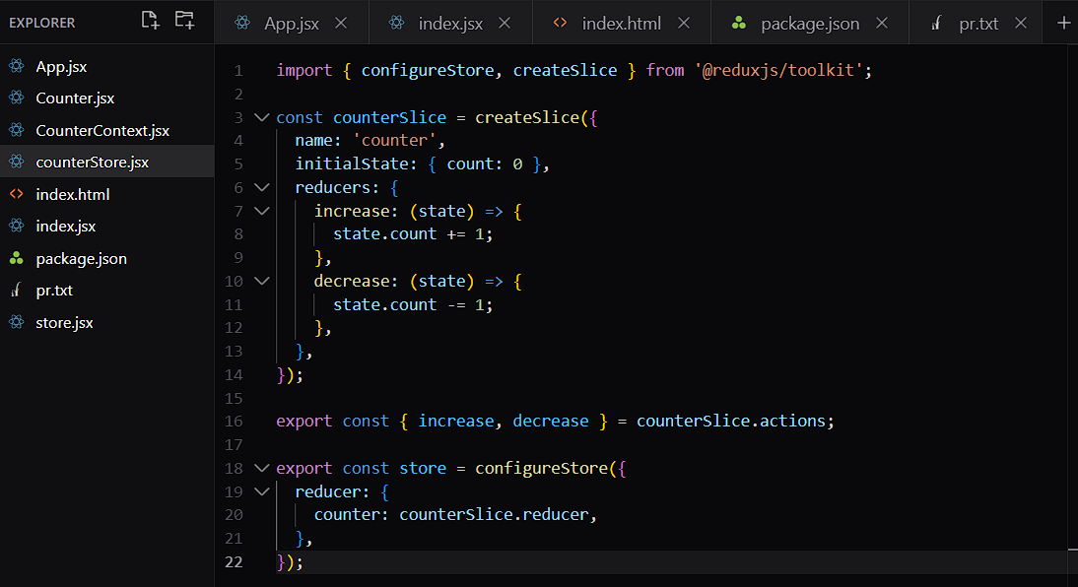
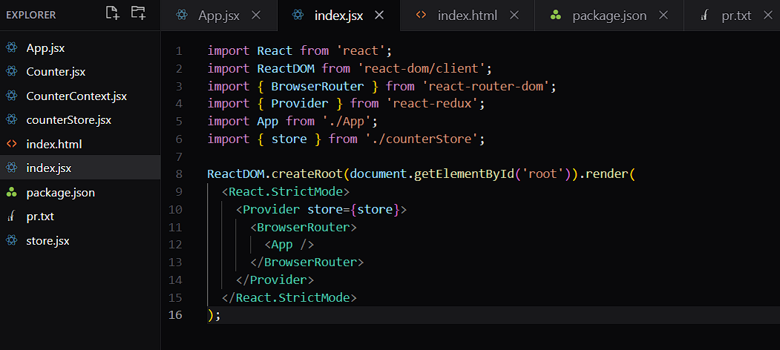
REACT DEVTOOLS

